Computer Systems
CFGS DAW



SECOND term
Assessable Activity

Álvaro Maceda
a.macedaarranz@edu.gva.es
2022/2023
Version:230502.1019
License


Attribution - NonCommercial - ShareAlike (by-nc-sa): No commercial use of the original work or any derivative works is permitted, distribution of which must be under a license equal to that governing the original work.

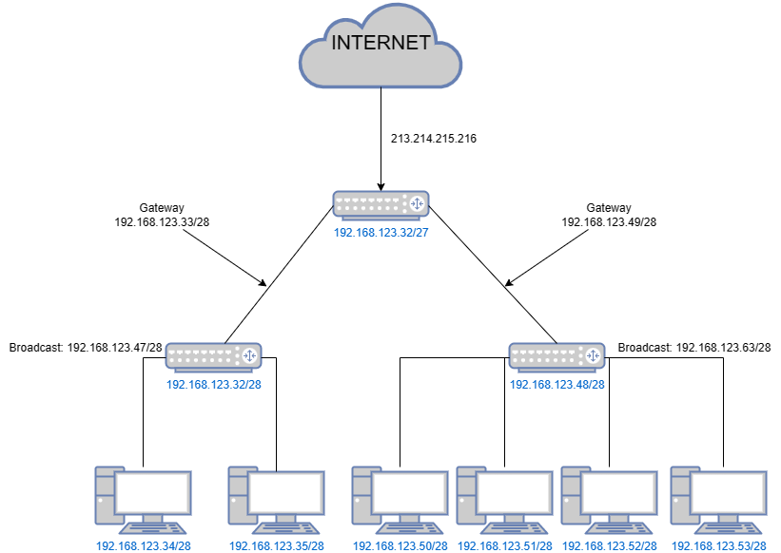
Second Term: Assessable activity

Exercise 1

Network topology

Network addresses
Network | Address
Network A – Start | 192.168.123.32/28
Network A – Finish | 192.168.123.47/28
Network B – Start | 192.168.123.48/28
Network B – Finish | 192.168.123.63/28

IP adresses
Network A
Device | IP
Device 1 | 192.168.123.34/28
Device 2 | 192.168.123.35/28
Router | 192.168.123.32/28
Broadcast | 192.168.123.47/28
Gateway: (192.168.123.33/28)
Network B
Device | IP
Device 1 | 192.168.123.50/28
Device 2 | 192.168.123.51/28
Device 3 | 192.168.123.52/28
Device 4 | 192.168.123.53/28
Router | 192.168.123.48/28
Broadcast | 192.168.123.63/28
Gateway: (192.168.123.49/28)

Exercise 2

Part 1

Content of files
File name: dockerfile
Contents:
FROM ubuntu:22.04
RUN apt-get update
RUN apt-get install -y openssh-server
RUN apt-get install openssl
RUN useradd -m -p "(openssl passwd -1 user1server)" user1
RUN useradd -m -p "(openssl passwd -1 user2server)" user2
RUN mkdir /var/run/sshd
RUN touch /etc/ssh/sshd_config.d/port.conf
RUN echo "Port 33" > /etc/ssh/sshd_config.d/port.conf
CMD["/usr/sbin/sshd", "-D", "-o", "ListenAddress=0.0.0.0"]
File name: port.conf
Contents:
Port 33

Command(s) to build the image
docker build -t server exercise3-server . #to connect use ssh <user>@<ip> -p 33

Part 2

Commands to launch the containers
docker network create ex3
docker create -t -i -p 22:33 --network ex3 --name ex3-server exercise3-server
docker create -t -i --network ex3 --name ex3-client ubuntu:22.04
docker start ex3-server
docker start ex3-client

Commands to test the service from the docker client
docker network inspect ex3 #to view containers ip's (in this case 172.19.0.2 server and 172.19.0.3 client)
docker exec -t -i ex3-client /bin/bash #to execute container with shell /bin/bash
apt-get update
apt-get install -y openssh-client
ssh user1@172.19.0.2 -p 33 #to connect with server

Command(s) to test the service from your host
apt-get update
apt-get install -y openssh-client
ssh user1@0.0.0.0

